

MASENO 2025 KCSE PREDICTION
CONFIDENTIAL EXAM
232/2
PHYSICS
PAPER 2 (THEORY)
TIME: 2 HOURS

NAME……………………………………………………………………………………….
SCHOOL……………………………………………… SIGN………………………..
INDEX NO……………………………………………. ADM NO……………………

INSTRUCTIONS TO CANDIDATES
- Write your name, Index number and School in the spaces provided above
- Sign and write the date of the examination in the spaces provided above
- This paper consists of two sections; A and B
- Answer all the questions in section A and B in the spaces provided
- All workings must be clearly shown in the spaces provided below each question
- Non programmable silent electronic calculators may be used.
- Candidates should answer the questions in English

FOR EXAMINER’S USE ONLY
Section | Question | Maximum  Score | Candidate’s  Score
A | 1 - 13 | 25
B | 14 | 11
 | 15 | 10
 | 16 | 12
 | 17 | 10
 | 18 | 12
Total Score |  | 80

SECTION A (25marks)
Answer all the questions in this section in the spaces provided
- Figure 1 below shows the set – up for a simple cell.
Bulb
Dil H₂SO₄

A

Copper plate

Figure 1.

(i) Explain how electrode A becomes negative (1mk)
......................................................................................................................
......................................................................................................................

(ii) Explain why the bulb goes off after only a short time. (1mk)
......................................................................................................................
......................................................................................................................

- a) Figure 2 shows an object, a screen and light sources X, Y and Z.
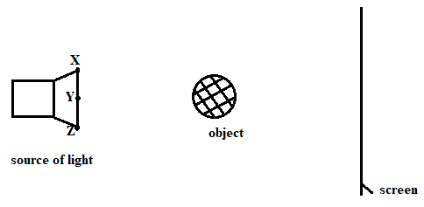
Figure 2.
- Complete the diagram to show the formation of a shadow (2mks)
- State one property of the object that makes it possible for its shadow to be formed (1mk)
......................................................................................................................
......................................................................................................................

- A highly negatively charged rod is gradually brought close to the cap of a positively charged electroscope. It is observed that the leaf collapses initially and then diverges. Explain the observation. (2mks)
......................................................................................................................
......................................................................................................................
......................................................................................................................

- Distinguish between thermionic emission and photoelectric effect. (1mk)
......................................................................................................................
......................................................................................................................
......................................................................................................................

- Explain why mains electricity is transmitted through alternating current and not direct Current (1mk)
......................................................................................................................
......................................................................................................................

- Figure 3 shows two mirrors inclined at an angle of 30º to each other. A ray of light is incident on mirrorM₁ as shown
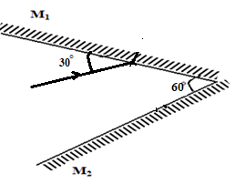
Figure 3.

Sketch the path of the ray to show its reflection (1mk)

- Figure 4 below shows sound waves in air produced by a vibrating tuning fork. R is an air molecule on the path of the waves.
R

Oscillation
Figure 4.

i) Using a line, indicate on the diagram a distance d equal to one wavelength of the wave. (1mk)

ii) In the space provided below, show with an arrow the direction of motion of the air
molecule R as the waves pass. (1mk)

- Figure 5 below shows a bar magnet attracting steel pin as shown

N
S
X
Y
Steel pin
Figure 5

State and explain what would happen when a North pole of a bar magnet is brought near the tips of steel pin X and Y. (2mks)
......................................................................................................................
......................................................................................................................
......................................................................................................................

- Figure 6 below shows a wave profile for a wave whose frequency is 5Hz.
t₃
t₅
t₇
t₉
t₁
Time (s)
Displacement (cm)

₁

-1
-2
Figure 6
2

Determine the value of t₈. (2mks)
......................................................................................................................
......................................................................................................................
......................................................................................................................
......................................................................................................................

- Figure 7 below shows circular waves originating from the principal focus F of a concave mirror and moving towards the mirror.

F
Figure 7

Complete the diagram to show the reflected waves. (1mk)

- Two heating coils A and B connected in parallel in a circuit produces power of 36W and 54W respectively. What is the ratio of the resistance of B to that of A (3mks)
......................................................................................................................
......................................................................................................................
......................................................................................................................

- Figure 8 below shows the path of light through a transparent material placed in air.
AIR
Transparent
material
Ray of light
139⁰

Figure 8.

Calculate the refractive index of the transparent material. (3mks)
......................................................................................................................
......................................................................................................................
......................................................................................................................
......................................................................................................................

- Figure 9 below shows an image; I formed by an object placed in front of a convex mirror. On the diagram draw appropriate rays and locate the position of the object. (2mks)
F
I
C

Figure 9.

SECTION B (55 marks)
Answer all the questions in this section in the spaces provided
- (a) Figure 10 below shows two charged plates close to each other
Figure 10.
+ + + + + + + + + + + + + + + -
- - - - - - - - - - - - - - - - - - - - - - - -

- Complete the diagram to show the electric field patterns between the plates (1 mark)

- Without changing the area of overlap, suggest any one way of increasing the charge stored per unit voltage on the plates (2 mks)
......................................................................................................................
......................................................................................................................
......................................................................................................................

(b) Figure 11 shows two coils P and Q placed close to each other. When the switch S is closed, an e.m.f is induced in coil Q. Similarly, an e.m.f is induced in coil Q when the switch S is opened.

P Q

S
Figure 11.
Explain why the induced current in coil Q is higher when the switch S in coil P is opened
than when it is closed. (2 mks)
......................................................................................................................
......................................................................................................................
......................................................................................................................

- The diagram in Figure 12 below shows an induction coil used to produce sparks.

B
A

C

Soft iron core Armature Contact

Figure 12.

(i) Name parts labeled A, and C (2mks)
A…………………………………………………………………

C…………………………………………………………………

(ii) Briefly explain how the induction coil works. (3mks)
......................................................................................................................
......................................................................................................................
......................................................................................................................
......................................................................................................................
......................................................................................................................

- State the function of part B in the diagram. (1mk)
......................................................................................................................
......................................................................................................................
......................................................................................................................

- (a) Figure 13 below shows a graph of resistance against reciprocal of current. Use it to answer the questions that follow.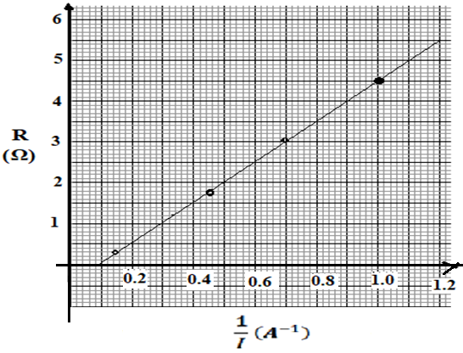
Figure 13
- Find the internal resistance, r. (2mks)
......................................................................................................................
......................................................................................................................
......................................................................................................................

- Determine the e.m.f, E of the cell. (2mks)
......................................................................................................................
......................................................................................................................
......................................................................................................................

(b) Three resistors of resistance 2 Ω, 3 Ω and 4 Ω, are to be connected to a cell such that they have the least effective resistance.
(i) Draw a circuit to show how they can be connected to achieve this. (1mk)

(ii) Determine the least effective resistance of the three resistors. (2mks)
......................................................................................................................
......................................................................................................................
......................................................................................................................
......................................................................................................................

(c) An electric iron rated 240V, 750w is to be connected to a 240v mains supply through a 3A fuse. Determine whether the fuse is suitable or not. (3mks)
......................................................................................................................
......................................................................................................................
......................................................................................................................
......................................................................................................................

- (a) (i) Name the metal used to shield X-rays operators from the radiation. Give reasons
why it is used. (2mks)
......................................................................................................................
......................................................................................................................
......................................................................................................................

(ii)In a television set, magnetic fields are preferred for use as deflection system instead of electric fields. Explain. (2mks)
......................................................................................................................
......................................................................................................................
......................................................................................................................

(b) Figure 14 below show regions of the complete electromagnetic spectrum.

A |  |  | Visible Light |  | B | C
X Y
Figure 14. Decreasing frequency

- Name the colour of light at X and Y (2mks)
X ………………………………………………
Y ………………………………………………
(ii) Name a suitable detector for radiation B (1mk)
......................................................................................................................

(c) A student connected a circuit as shown in Figure 15 below, hoping to produce a rectified output.
X

To C.R.O
R
D
1
D
2
a.c

Y

Figure 15.
- Sketch the graph of the output on the CRO screen in the space below. (1mk)

(ii) Explain how this output is produced (2mks)
......................................................................................................................
......................................................................................................................
......................................................................................................................

- The figure shows a current – carrying conductor in a magnetic field direction of force on the wire is as shown by the arrow.
Force

Y
X

State the polarities of A and B. (2mks)
X ……………………………………………………..
Y. ………………………………………………………

- (a) A typical nuclear fission reaction in a nuclear reactor is given below.
$$\frac{235}{92}U + \frac{1}{0}n\underset{→}{ }\frac{148}{57}La + \frac{85}{35}Br + x \frac{1}{0}n$$

(i) What is meant by nuclear fusion? (1mk)
......................................................................................................................
......................................................................................................................

(ii) Find the value of x. (1mk)
......................................................................................................................
......................................................................................................................

(iii) How are the neutrons produced used in the reactor? (1mk)
......................................................................................................................
......................................................................................................................
......................................................................................................................

- Figure 16 below shows the diagram of a Geiger – Muller tube connected to a power supply and a pulse counter.
Anode
Pulse counter
Mica window

R
Argon and bromine gas at low pressure
Cathode
400kV
Insulator
Radiations
Figure 16
(i) Why should the Argon gas be at low pressure? (1mk)
......................................................................................................................
......................................................................................................................

- State the purpose of the bromine gas in the tube (1mk)
......................................................................................................................
......................................................................................................................

- Suggest one way of increasing the sensitivity of the tube (1mk)
......................................................................................................................
......................................................................................................................

(c) Figure 17 below shows an arrangement used to investigate photoelectric effect
Colour filter
J

V

C

A

White Light
+
-
μΑ

Figure 17
i) What is the purpose of the colour filter? (1mk)
......................................................................................................................
......................................................................................................................

ii) State two measurable quantities in this set up (2mks)
......................................................................................................................
......................................................................................................................

iii) State how the intensity of light affects photo current (1mk)
......................................................................................................................
......................................................................................................................
......................................................................................................................

- (a) Under what conditions does a converging lens form Virtual images (1 mk)
......................................................................................................................
......................................................................................................................

(b) Sketch on a diagram to illustrate how a convex lens is used as a magnifying glass. 3mks)

(c)The diagram in Figure 18 below shows a three-pin plug.
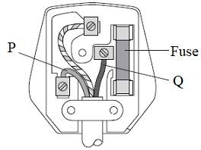
Figure 18.
- Name the colour of conductors P and Q (2 marks)
P ……………………………………………………………………………………
Q ……………………………………………………………………………………

- Why is the earth pin longer than the rest in the three-pin plug shown above? (1 mark)
......................................................................................................................
......................................................................................................................
......................................................................................................................

- Figure 19 shows the displacement of a practice in progressive wave incident on a boundary between deep and shallow regions.

Deep
Shallow

Figure 19.

- Complete the diagram to show what is observed after boundary. (1mk)

- Explain the observation in (i) above. (1mk)
......................................................................................................................
......................................................................................................................

- Concave mirrors are used by dentists to examine teeth. By use of a ray diagram show how this is achieved. (3 marks)

THIS IS THE LAST PRINTED PAGE

